**How to use, store and clean the thermos bottle properly**

**Use the thermos bottle properly**

For the first-use thermos bottle, before using it, use a dishwashing liquid or baking soda powder (bought at supermarkets) or vinegar to clean and deodorize the new product in the bottle. Thus, when using water storage tank will not affect the taste and quality of water used.

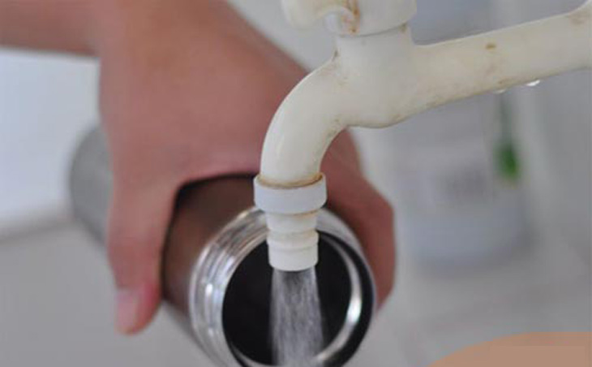

The thermos bottle usually has 2-3 layers, it should be noted that the average structure is used to keep cold or can store hot - cold drinks to ensure the efficiency of keeping heat as required.

With hot and cold thermos, some products have a heat resistance level below boiling point, at about 70 - 80 degrees Celsius, it should be noted that to avoid overheating of water can cause damage to the jar or cause reacting to the material of the surface of the flask producing harmful substances.

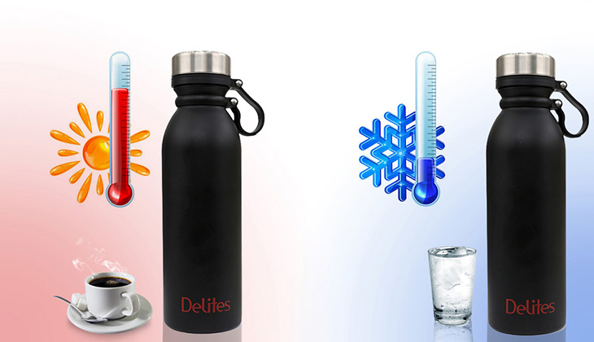

Do not pour water or drinks close to the mouth of the bottle, easy to overflow when closing the lid and do not achieve the best heat preservation effect. An air gap should be left on the surface of the flask to provide a longer heat-retaining effect.

Users should not put the thermos in the refrigerator, because the liquid in the bottle will expand when it is cold and deform the flask, reduce or lose the heat retention effect of the product.

Also do not use them in the microwave, because the thermos bottle made of metal is easy to cause fire

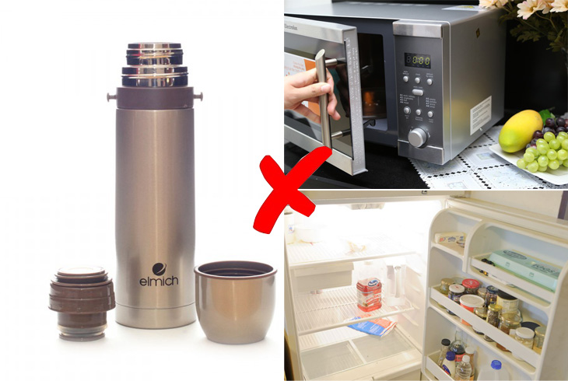

Finally, after putting the drink in the bottle, check the lid to close tightly, joints to keep the bottle closed and keep the best heat, avoiding water leakage when moving.

**Preserving thermos**

In the process of using and storing, avoid impact or force too strong impact on the bottle will make the bottle distorted, making two metal layers collide with each other, reducing the space between two layers of metal leading to the ability to hold Heat decreases.

Should give the bottle a "breathing distance" between 2 times of hot water storage - cold continuously. If you are hot water and want to switch to cold water (or vice versa), you need to leave the bottle with a spacing of about 10-15 minutes. The sudden change in temperature will cause the material in the bottle to relax suddenly, affecting the life and quality of use.

Immediately after use, the thermos bottle should be cleaned soonest and then stored in a dry place to avoid arising mold, bacteria accumulate and smell the drink.

**How to clean the thermos bottle**

First of all, it should be noted, absolutely do not use strong detergents, corrosive solutions (bleach, acetone ...) to clean the thermos bottle.

When using normal water, the bottle only needs to be washed and dried or dried naturally to be used.

After storing the drinks to keep the smell, keep other residues, the bottle should be cleaned more thoroughly to avoid moldy, bacteria and affect the next use.

**Some ways to remove odors, clean heat preservation bottles:**

Method 1: Use warm water mixed with dishwashing liquid and pour into the bottle, cover tightly to overnight. The next morning you rinse with clean water.

Method 2: Use newspaper and warm water. Squeeze the newspaper and place it in a covered container, leave for 2-3 days, then remove the newspaper and rinse it with warm water, in a dry place.

Method 3: Use 1 tablespoon of baking soda mixed with warm water and pour into a covered bottle overnight. The next day you rinse the bottle with warm water and leave it in a dry, cool place to clean off the unpleasant odor.

Method 4: Use 1 tablespoon of baking soda mixed with apple cider vinegar or lemon juice, pour into a jar and close the lid and shake vigorously several times. Then pour this water and clean the jar again with warm water. This method is very effective for cleaning bad smell long, difficult to wash in the thermos bottle.